INTRODUCTION

1.1 PROJECT DESCRIPTION

This project was undertaken at Nyeras (NYERAS Edu-tech and Innovations Pvt. Ltd.), an online educational platform focused on career acceleration and skill enhancement.
The goal of developing this task management system is to create an intelligent, responsive, and scalable web application that would allow students to register themselves and perform various operations such as authentication, management of tasks, tracking of progress, and generation of subtasks using artificial intelligence. This system was developed using the JavaScript full stack, which consists of Node.js, Express.js, React.js (using Vite), and MySQL.
The platform incorporates essential student productivity features including user authentication and profile management, task and subtask creation with CRUD operations, AI-powered task breakdown using Google Gemini 2.5 Flash, a daily planner view, an Eisenhower priority matrix, productivity analytics with a heatmap grid, and automated deadline reminders. An AI controller was also built to interface with the Gemini API, generating 4 to 6 actionable, time-estimated subtasks per assignment along with a personalised success strategy — providing students with structured guidance beyond a simple to-do list. React.js was used in front end development due to its ability to offer a component based framework and render content dynamically. The frontend also had a neat and responsive user interface that ensured better usability of the application.
Backend technology was selected based on Node.js and Express.js to ensure non-blocking server performance. MySQL was used in database design and is interfaced through the mysql2 driver for data handling.. The routes are categorized by domains, including user, task, analytics, and AI, all of which are handled by a middleware layer that provides authentication through JWT. APIs were designed in line with the REST approach to provide modularity and maintenance ease. The project had a scheduled background process using the node-cron package which runs daily in the morning to determine tasks to be done tomorrow.
This project has provided practical training in web development. Apart from deepening knowledge in full-stack development, the project has offered exposure to software development practices like modular programming, authentication, API designing with large language models, database designing, and user interface/user experience design. Participation in this project provided improvement in problem-solving skills and effective time management, important for professional software development.

1.2 MOTIVATION

Indeed, the swift advancement of technology in student work has revolutionised the way students approach organisation, planning, and execution of tasks. Intelligent technologies are becoming ever more prominent. As such, student task management systems require development to ensure user-friendliness and technological innovation. Tasklytic, therefore, can be seen as a result of such conceptualisation and development. Technically speaking, a major reason for the need to develop the project includes the creation of a web application that was responsive, secure, scalable, and modular using the latest full-stack development technology stack. Full-stack JavaScript-based solutions are becoming increasingly popular because they provide full development capabilities and can serve the development process very well. The following four technologies make up the selected full stack:

• React.js (Vite) – A highly useful library for creating interactive and dynamic frontends.
• Node.js – A runtime environment that allows developing robust server-side solutions.
• Express.js – A minimalistic web application framework designed specifically for Node.js.
• MySQL – A dependable and efficient relational database management system.

The following were some of the challenges that motivated the choice of the selected technology and design approaches in Tasklytic.
- Scalability and Structured Data Handling
Using MySQL with the mysql2 driver enables Tasklytic to efficiently manage an increasing amount of structured data ranging from user accounts, tasks, subtasks, logs, and heatmap activities. The use of relational tables ensures consistency among connected objects while capturing information such as multiple subtasks contained within a task, with each having its status and estimation period.
- Performance and User Interface Efficiency
React provides a high-performance interface that is able to update sections of the interface without the need to re-render the whole page when a student uses components such as task manager, daily planner, Eisenhower matrix, and analysis dashboard. The use of React components also makes it easy to write reusable code by using pages such as TaskDetail, Dashboard, and Analysis.
3. Security and User Authentication
Using Express.js and Node.js for the backend, the platform enjoys strong routing and middleware capabilities. User authentication and secure sessions have been facilitated by implementing JWT (JSON Web Tokens), which allows for secure routes, encryption during client-server interaction, and safe processing of sensitive user information such as passwords and security questions. Password recovery and resetting functionalities have been implemented using Nodemailer for comprehensive account protection.
4. AI Integration and Intelligent Extensibility
The main inspiration for designing Tasklytic involved the integration of a generative artificial intelligence component within the student workflow. The Google Gemini 2.5 Flash API was built into the task cycle to automatically break down any assignment into 4 to 6 subtasks with estimations of time and effort, alongside offering a customized success plan. The example above highlights the extensible nature of the modular Node.js framework, providing for seamless integration with external AI services.

5. Automation and Proactive Notifications
The system makes use of node-cron to schedule background processes that find tasks to be performed on the next day and sends the users automated rich HTML formatted reminder emails via Nodemailer. With this automation in place, no task will ever be missed due to lack of awareness as there is zero need for manual effort to send such notifications.

6. Developer Productivity and Maintainability
With a consistent JavaScript stack implemented in both front and back ends, this project enjoys better development productivity as developers do not require switching contexts between different languages. The routes have been segregated based on the type of data they handle, including user, task, analytics, and AI with their own controllers and services as part of a clear modular structure.

1.3 EXISTING AND PROPOSED SYSTEM

Current systems that manage tasks in students' workflows consist of universal productivity software like Microsoft To-Do, Notion, Google Tasks, or Trello. These apps allow users to perform essential functions like creating new tasks, assigning deadlines to them, and tracking their progress to some extent. Nevertheless, they do not include any functionality that is specifically designed for students. For example, they do not have features related to intelligent task decomposition, categorization, estimating study efforts, or generating reminders based on deadlines. Current solutions have an ordinary template without any customization possibilities and, consequently, lower student engagement and productivity.

Moreover, productivity analysis tools like heatmap grids or the Eisenhower matrix are either unavailable or can be found only as part of the paid version of those apps. The integration with AI that will help with studying efficiently is impossible or too costly to implement through third-party applications.

Disadvantages of Existing System include:

• Generic systems are not tailored for student purposes and do not have features like task categorization, estimating subtasks' time requirements.
• AI integration is missing in most tools, and students are required to perform a task breakdown manually.
• Productivity data analysis, including completion heatmap, effort level, and workload balance chart creation, is not implemented in free version apps.
• Automated reminder of deadlines is either absent from systems or should be set up manually via third-party integration services.
• The concept of priority organization, for example, via Eisenhower Matrix, cannot be realized due to lack of relevant tools.

• Planner for each day dedicated to specific courses subtasks' organization is not provided.
• Information is scattered across separate applications, which reduces consistency of productivity system of a student.

PROPOSED SYSTEM
The new system will be referred to as Tasklytic and is a purpose-built intelligent AI-powered student task management system that will address students' specific coursework, assignment, and schedule management needs. As opposed to common productivity tools like Notion or Trello, which do not have an student-oriented interface, this system will be built in such a way as to be both useful and intelligent, as well as to emphasize task structuring, AI guidance, and automation. The software has been implemented using a modern JavaScript full stack, including React.js (Vite), Node.js, Express.js, and MySQL technologies.
Tasklytic was conceived with three main objectives in mind. First, a system was required that would allow all the student tasks and their subtasks to be created and tracked from a single place. Second, an integration of the Google Gemini AI technology needed to be performed to facilitate the splitting of assignments into subtasks with estimated time and unique study approaches for each of them. Finally, the system should enhance the users' level of involvement and consistency through the use of various elements like productivity heatmaps, daily planners, Eisenhower matrices, and reminders.
The advantages of meeting these goals will be substantial compared to other software products. The platform offers student-specific experience with its own customized interface, course-wise organization of content, and artificial intelligence-based recommendations related to the workflow of students. Task segmentation through the power of Google Gemini AI will ensure the breaking down of each task into four to six smaller actions with their respective deadlines and strategies for completing them, minimizing the burden on students to the minimum. Notifications for deadlines will be done using the Cron-based email alert system that sends notifications to the users the previous day when their respective tasks are due without any intervention from the user side. .
To deliver on these objectives and advantages, Tasklytic is built around the following core features:
- Sign-up/Login: Sign-up process incorporating JWT, encryption of the user password using bcrypt, and forgot password implementation with Nodemailer.
- Task/Subtask Management: Complete task management with features like create, read, update, delete for tasks. Support for title, description, category, due date, priority and status of the student tasks.
- AI-Based Task Splitting: Google Gemini 2.5 Flash to extract structured subtasks from the input task, time estimation of completing the subtasks, effort level required for the subtask and study tip personalized to the task.
- Daily Task Planner: View subtasks that are due today. Helps students focus on their immediate work.
- Eisenhower Matrix: Priority matrix based on the task's urgency and importance. Makes the task selection a conscious process.
- Productivity Metrics & Heat Map: Visualization of completion rates, percentage of tasks completed from each category, and activity chart similar to Github commit trend.
- Tasks Reminder Emails: Background job using node-cron package sends email reminders of tasks that are due tomorrow, automatically.
- User Settings: Option for the user to update their profile information, passwords and security questions from settings tab.

1.4 HARDWARE AND SOFTWARE REQUIREMENTS

    - HARDWARE SPECIFICATION

Table 1 Hardware Specification
Component | Specification
Processor (CPU) | Intel Core i5 / i7
RAM | Minimum 8 GB
Storage | 256 GB SSD
Operating System | Windows 10 / 11
Network | Stable broadband internet connection (≥ 20 Mbps)

SOFTWARE SPECIFICATION

Table 2 Software Specification
Category | Software / Technology (with Version)
Frontend | React.js v19.x (Vite 5.x build tool)
 | JavaScript ES2022
 | HTML5, CSS3
 | React Router DOM v7.x
Backend | Node.js v18.17.1
 | Express.js v5.2.1
Database | MySQL v8.0+ (with mysql2 v3.x driver)
ORM / Query | mysql2 with connection pooling
Authentication | JSON Web Token (JWT) v9.0.x + bcrypt v6.x
AI Integration | Google Gemini 2.5 Flash API (@google/generative-ai v0.24.1)
Email Service | Nodemailer v8.x
Scheduler | node-cron v4.x
Code Editor | Visual Studio Code v1.90.0
Version Control | Git v2.43.0 + GitHub
Web Server | Node.js Server with Express Middleware
Operating System | Windows 10 / 11
Browser  Compatibility | Google Chrome v138.0.7204, Mozilla Firefox v140.0, Microsoft Edge  v138.0.3351.65, Safari v18.5

SYSTEM ANALYSIS

2.1 FEASIBILITY STUDY
Feasibility analysis plays a crucial role in assessing the viability of a project in terms of design, development, and implementation. The feasibility analysis of Tasklytic — an intelligent task management system for students that leverages AI — has been performed from four different perspectives: technical feasibility, operational feasibility, economic feasibility, and scheduling feasibility.
2.1.1 TECHNICAL FEASIBILITY
The proposed Tasklytic solution is feasible from a technical perspective because the suggested solution leverages modern JavaScript full stack technologies such as React.js (Vite), Node.js, Express.js, and MySQL. All these technologies are not only free to use, but they are open-source, popular, and widely implemented in practice.
MySQL paired with the mysql2 driver offers structured and relational database storage of user, task, subtask, analytics logs, and heatmap activities. The database's relational schema helps in maintaining data consistency between entities and provides complex querying for analysis and scheduled jobs. In the backend side, Node.js paired with Express.js is used, which provides a lightweight and highly efficient runtime environment together with a solid web application framework for processing API routes, implementing middleware, scheduling jobs, and server functionality. For creating the front end part of the application, React.js is used together with the Vite build tool, which allows constructing the front end part in a more efficient way while ensuring that all the features of React.js are utilized. One of the major benefits of the proposed software stack is the ability to code all parts of the application in one programming language, namely, JavaScript. Moreover, the system makes use of external third-party libraries implementing various useful functionalities, including JSON Web Token-based authentication, hashing passwords with bcrypt, sending emails with Nodemailer, background job scheduling with node-cron, and task decomposition with the help of Google Gemini 2.5 Flash API. Considering the aforementioned factors, the application is entirely ready for performance.
2.1.2 OPERATIONAL FEASIBILITY
In terms of feasibility, the system is very feasible because it provides an effective and convenient way for students to manage their academic assignments. They are able to sign up for an account, log in securely, organize their assignments based on course categories, get an automatic breakdown of each assignment into subtasks using artificial intelligence, monitor their progress using the planner, and receive automatic emails reminding them about upcoming deadlines.
With the help of AI integration through Google Gemini, planning your assignments will be much easier since you will automatically get a detailed plan. With secure JWT authentication, users will be able to protect their information, as there will be bcrypt encrypted passwords and a possibility to reset passwords using emails. The use of the Eisenhower Matrix and Productivity Heat Map will provide students with a tool that will help them prioritize their activities and assess their study discipline without the need to depend on any external tool like an Excel spread sheet or other similar software to track their performance. In addition, the automated cron job based emailing system works automatically and sends out all deadline reminders without any involvement at all from the student. Lastly, the settings page enables students to control everything about themselves independently.
2.1.3 ECONOMIC FEASIBILITY
The solution is economically feasible, and hence affordable, which makes it ideal for individual students and educational institutions. It involves the use of all open-source solutions, thus, avoiding the costs associated with using expensive proprietary software and licenses. MySQL databases can be deployed on various free-tier cloud computing databases, while the frontend and backend can be initially launched on various platforms such as Vercel at zero cost, and then scaled later depending on the traffic.
It involves the use of a free tier in Google Gemini API, which is adequate for development and even moderate production purposes. With regard to the cost-effectiveness of the design, the implementation involves the use of a modular codebase in which controllers, services, and routes are easily identifiable and thus easily updatable or replaceable in the future. The use of free-tier email service providers and Nodemailer ensures that there are no costs associated with the use of transactional emails in the early stages of deployment. All in all, the automated tasks, analytics, and AI features eliminate the need for expensive tutoring or subscription plans.
2.1.4 SCHEDULING FEASIBILITY
The project development process utilized the Agile methodology, which is a flexible and iterative project management methodology that emphasizes rapid delivery and iterative planning. The use of the Agile development methodology allowed for an efficient development process, as well as a systematic approach to each development stage. The development process included several stages, each of which involved different processes, including requirement gathering – user stories, technical specification, and prioritization; UI/UX design – page wireframe development.
Back-end development included the creation of the modular architecture of the application that includes user authentication, task/subtask management, integration of AI technology, analytics, and scheduling emails. Meanwhile, front-end development involved making sure that all pages are responsive and integrated with back-end services via RESTful API. Sprint cycles were implemented during each module development. Each sprint cycle included different modules, such as user registration/login, task management CRUD operations, AI tasks breakdown, daily planner, Eisenhower matrix, heatmap analytics, and scheduling email services.
The use of GitHub enabled version control via proper code management using techniques such as branches, pull requests, and commit messages. The code was reviewed at regular intervals to make sure that its quality was up to the mark. Both unit testing and integration testing were performed in each sprint in order to test the functioning of all modules. The documentation of software development process was done at the same time, which included the documentation of APIs and procedures for software deployment. The project could be successfully developed within the proposed timeframe because of proper management of time, proper division of work into modules, and the use of Agile approach.

PROJECT PLAN

The process of developing Tasklytic was carried out systematically through various phases.

Phase 1: Requirement Analysis (Week 1-2) Requirements along with project goals were defined as well as features, roles of users, and priority order. This phase was the basis for all other development tasks.

Phase 2: UI/UX Design (Week 3-4) Wireframes and mockups were made for each of the main pages such as Dashboard, task detail page, daily planner, Eisenhower matrix, and analytics. Finally, design guidelines including color schemes, fonts, and layout structure were determined.

Phase 3: Environment Setup (Week 5) Environment was prepared by installing React (Vite), Node.js, Express.js, MySQL for backend, and initialising a GitHub repository for version control purposes. Database was established locally to develop simultaneously both backend and frontend.

Phase 4: Backend Development (Week 6-9) RESTful APIs were implemented using Express.js for performing tasks related to user registration, tasks and subtasks operations, generation of analytics information, and implementing AI. MySQL schemes and JWT, bcrypt algorithms for passwords security and emailing services via Nodemailer were introduced.

Phase 5: Frontend Development (Week 10-13) React.js was used for frontend implementation together with Vite. Page navigation was implemented using React Router, and components were created to reuse them in different parts of application.

Phase 6: AI Integration Module (Weeks 12–13)
The controller was created to connect to the Google Gemini 2.5 Flash API to automatically decompose tasks to 4–6 subtasks with estimates of duration and effort classification. An AI-unavailable scenario was accounted for in the design as a fallback option.

Phase 7: Testing & Debugging (Weeks 14–15)
The testing of the product, including unit, integration, API, and UI/UX testing was performed. All bugs in terms of handling data, using cron jobs, and parsing from API were detected and fixed.

Phase 8: Deployment & Hosting (Week 16)
The backend and frontend products were deployed on Vercel with cloud-based database MySQL server. All environment variables, keys to API, and production mode were checked.

Phase 9: Documentation & Report (Weeks 16–17)
This phase includes finishing the project report and user manual. It is done simultaneously with deployment for efficiency in the time left before the deadline.

Phase 10: Final Presentation Preparation (Week 18)
This week will be dedicated to preparing the presentation, live demo, and ensuring viva readiness by thoroughly checking all systems.

3.2 GANTT CHART
Below is the Gantt chart representing the schedule of development phases over an 18-week period, showcasing task sequencing and parallelism of activities and their dependencies .

Phase / Activity | W1 | W2 | W3 | W4 | W5 | W6 | W7 | W8 | W9 | W110 | W111 | W12 | W13 | W14 | W15 | W16 | W17 | W18
Requirement Analysis | ✓ | ✓
UI/UX Design |  |  | ✓ | ✓
Environment Setup |  |  |  |  | ✓
Backend Development |  |  |  |  |  | ✓ | ✓ | ✓ | ✓
Frontend Development |  |  |  |  |  |  |  |  |  | ✓ | ✓ | ✓ | ✓
AI Integration Module |  |  |  |  |  |  |  |  |  |  |  | ✓ | ✓
Testing & Debugging |  |  |  |  |  |  |  |  |  |  |  |  |  | ✓ | ✓
Deployment & Hosting |  |  |  |  |  |  |  |  |  |  |  |  |  |  |  | ✓
Documentation & Report |  |  |  |  |  |  |  |  |  |  |  |  |  |  |  | ✓ | ✓
Final Presentation Prep |  |  |  |  |  |  |  |  |  |  |  |  |  |  |  |  |  | ✓
Figure 1 Gantt Chart For Tasklytics

SOFTWARE REQUIREMENTS SPECIFICATIONS (SRS)

4.1 Introduction

4.1.1 Purpose
This Software Requirements Specification describes the complete set of functional and non-functional requirements for the AI-Powered Student Task Management System, Version 1.0. The system is a full-stack web application designed to reduce the cognitive burden on students by bringing task organisation, AI-assisted planning, and productivity monitoring together in one cohesive platform.
The application is built on a React frontend, a Node.js/Express.js backend, a MySQL relational database, and the Google Gemini 2.5 Flash API for AI-driven features. This document covers all three tiers of that architecture and serves as the binding agreement between stakeholders, developers, and evaluators throughout the project lifecycle.

4.1.2 Product Scope
The AI-Powered Student Task Management System is a self-contained web application that enables students to create, manage, and track academic tasks — augmented at every stage by artificial intelligence.
Four goals shape the product's design. First, cognitive load is reduced by delegating task decomposition to the Google Gemini 2.5 Flash API, which automatically generates structured subtasks from a high-level description. Second, time management is improved through the Eisenhower Matrix and Daily Planner. Third, consistency is encouraged through a Pomodoro-based focus timer. Fourth, long-term insight is delivered through analytics dashboards and activity heatmaps.

4.2 Overall Description

4.2.1 Product Perspective
The AI-Powered Student Task Management System is a new, independently developed web application created as an MCA Major Project at BMS College of Engineering. It draws inspiration from tools such as Todoist and Notion but goes further by embedding AI-driven planning features designed specifically for academic use.
The system comprises three tiers: a React.js SPA on the frontend (deployed on Vercel), a Node.js/Express.js REST API on the backend (deployed on Render), and a MySQL database hosted on Aiven Cloud. Two external services complement this — the Google Gemini 2.5 Flash API for AI task breakdown and Nodemailer for automated email reminders.

4.2.2 Product Functions
- User registration, authentication, and profile management
- Task creation, editing, filtering, and deletion
- Subtask management with independent progress tracking
- AI-powered subtask generation and effort classification via the Gemini API
- Daily Planner view for narrowing focus to current-day tasks
- Eisenhower Matrix for priority-based task visualisation
- Productivity analytics including completion charts and an activity heatmap
- Automated HTML email reminders for tasks approaching their deadlines
- Account settings covering password management, notification preferences, and security questions

4.2.3 User Classes and Characteristics
User Class | Description
Student (Primary User) | Creates and manages tasks, triggers AI breakdowns, monitors progress through analytics, and uses the daily planner. A moderate level of technical proficiency is assumed.
Administrator (Future Scope) | An administrative role for managing user accounts is anticipated for future versions. Not implemented in v1.0.

4.2.4 Operating Environment
- Client Side: Any modern web browser (Chrome, Firefox, Safari, Edge) on Windows, macOS, Android, or iOS.
- Server Side: Node.js v18+ on a Linux environment hosted by Render.
- Database: MySQL 8.0 managed by Aiven Cloud.
- Frontend Hosting: Vercel, with CDN-backed static deployment.
- Connectivity: An active internet connection is required for all features.

4.2.5 Design and Implementation Constraints
- The backend must be implemented in Node.js/Express.js with MySQL as the sole relational database engine.
- AI functionality is bound to the Google Gemini 2.5 Flash API in v1.0.
- Session management relies exclusively on JWT tokens.
- All sensitive credentials must be stored in server-side environment variables and never committed to version control.
- The frontend must remain a React SPA; server-side rendering is out of scope for v1.0.

4.2.6 Assumptions and Dependencies
Assumptions
- Users have a stable internet connection for the duration of any active session.
- The Google Gemini 2.5 Flash API remains accessible under current usage limits.
- Real-time collaboration between users is out of scope for v1.0.
Dependencies
- Google Gemini 2.5 Flash API — required for AI task generation; unavailability triggers fallback logic.
- Aiven MySQL Cloud Service — required for all data persistence.
- SMTP Service — required for email reminders and password reset OTPs.
- Vercel and Render — required for frontend and backend hosting.

4.3 External Interface Requirements

4.3.1 User Interfaces
The interface is built with React around a principle of consistent, low-friction interaction. A persistent navigation sidebar and header remain accessible on all pages. All input forms include inline validation with real-time error messages. Layout is fully responsive, adapting to desktop, tablet, and mobile screen sizes using Flexbox and CSS Grid.

4.3.2 Hardware Interfaces
The system does not depend on any specialised hardware. It runs entirely within a standard web browser on any internet-connected device.

4.3.3 Software Interfaces
Component | Interface Description
Google Gemini 2.5 Flash API | REST API over HTTPS. Receives task title, description, and category; returns 4–6 subtasks with time estimates, a study tip, and an effort classification.
MySQL 8.0 (Aiven) | Accessed via the mysql2 Node.js driver using connection pooling. Schema includes users, tasks, subtasks, and settings tables with foreign key constraints.
Nodemailer (SMTP) | Handles email dispatch for password reset OTPs and daily deadline reminders over TLS-secured SMTP.
JWT (jsonwebtoken) | Signs and verifies access tokens for all protected API routes via authentication middleware.
bcrypt | Hashes passwords before storage and verifies hashes during login. Plaintext passwords are never persisted.

4.3.4 Communications Interfaces
All client-server communication travels over HTTPS. The frontend interacts with the backend exclusively through RESTful HTTP/JSON API calls. Email communication uses SMTP with TLS encryption via Nodemailer. Background email reminders are triggered by a node-cron scheduler running server-side on a daily schedule.

4.4 System Features and Functional Requirements

4.4.1 User Management (Priority: High)
REQ-1.1: The system shall allow new users to register using a unique email address and a password that meets minimum strength criteria.
REQ-1.2: The system shall authenticate users using email and password, issuing a signed JWT token upon successful verification.
REQ-1.3: The system shall allow authenticated users to update their display name and email address from the settings page.
REQ-1.4: The system shall provide a password recovery mechanism via a time-limited, single-use OTP delivered to the user's registered email address.
REQ-1.5: The system shall allow authenticated users to change their password, requiring verification of the current password before the change is accepted.
REQ-1.6: The system shall allow users to set and update a security question and answer as a supplementary account recovery mechanism.

4.4.2 Task Management (Priority: High)
REQ-2.1: The system shall allow users to create tasks with the following attributes: title, description, course category, due date, priority level, and completion status.
REQ-2.2: The system shall support filtering of the task list by category, priority, status, and due date, individually or in combination.
REQ-2.3: The system shall allow users to edit any attribute of an existing task at any point before or after completion.
REQ-2.4: The system shall allow users to delete tasks, with cascading deletion applied to all associated subtasks.
REQ-2.5: The system shall display a task detail view showing subtasks, AI-generated study tips, effort classification, and a progress indicator.

4.4.3 Subtask Management (Priority: High)
REQ-3.1: The system shall allow users to add subtasks to any task, with each subtask carrying a title and an estimated completion time.
REQ-3.2: The system shall allow users to mark individual subtasks as complete, with the parent task's progress percentage updated automatically.
REQ-3.3: The system shall allow subtasks to be edited or deleted independently without altering the parent task.
REQ-3.4: The system shall display a Daily Subtask View surfacing all subtasks due on the current date.

4.4.4 AI-Powered Task Breakdown (Priority: High)
REQ-4.1: The system shall send task title, description, and category to the Gemini 2.5 Flash API and receive a structured list of 4–6 subtasks, each with an estimated time allocation.
REQ-4.2: The system shall display a personalised study tip and an effort classification (low, medium, or high) alongside the AI-generated subtasks.
REQ-4.3: The system shall implement a fallback mechanism that generates default subtasks whenever the Gemini API is unavailable or times out.

4.4.5 Daily Planner (Priority: Medium)
REQ-5.1: The system shall display all subtasks due or assigned to the current date in the Daily Planner view in a focused, distraction-free layout.
REQ-5.2: The system shall allow users to mark subtasks as complete directly from the Daily Planner without navigating to the parent task.

4.4.6 Eisenhower Matrix (Priority: Medium)
REQ-6.1: The system shall display tasks across four Eisenhower quadrants — Do First, Schedule, Delegate, and Eliminate — classified by urgency and importance.
REQ-6.2: The system shall allow users to update a task's priority or completion status directly from within the matrix view.

4.4.7 Productivity Analytics and Heatmap (Priority: Medium)
REQ-7.1: The system shall display task completion rate trends over user-selectable time periods using line and bar charts.
REQ-7.2: The system shall display a GitHub-style activity heatmap showing daily task activity density over a rolling period of weeks and months.
REQ-7.3: The system shall display effort and workload distribution broken down by course category.

4.4.8 Automated Email Reminders (Priority: Medium)
REQ-8.1: The system shall run a scheduled background job on a daily cycle that identifies all tasks due the following day across users with email notifications enabled.
REQ-8.2: The system shall send formatted HTML reminder emails including the task title, course category, due date, and a direct link to the task in the application.

4.4.9 Settings and Account Management (Priority: Medium)
REQ-9.1: The system shall allow users to update their display name and email address from the settings page.
REQ-9.2: The system shall allow users to change their password, requiring verification of the current password before accepting the update.
REQ-9.3: The system shall allow users to view and update their security question and answer.
REQ-9.4: The system shall allow users to manage their email notification preferences, with changes reflected immediately in the reminder dispatch logic.

4.5 Non-Functional Requirements

4.5.1 Performance
Standard pages must load within an acceptable time under normal network conditions, achieved through optimised API calls, connection pooling, and CDN-backed static delivery. The Gemini API integration must implement configurable timeouts and fallback logic so that slow AI responses never block the UI. Database queries must use appropriate indexing on high-frequency columns (user_id, due_date, status).

4.5.2 Safety
The database enforces referential integrity constraints, including cascading deletion of subtasks when a parent task is removed. The system requires explicit user confirmation before any destructive action.

4.5.3 Security
REQ-SEC-1: All data transmission must use HTTPS with TLS encryption.
REQ-SEC-2: All protected API routes must require a valid, unexpired JWT token enforced by authentication middleware.
REQ-SEC-3: Passwords must be hashed using bcrypt before storage. Plaintext passwords must never appear in the database, logs, or any API response.
REQ-SEC-4: Password reset tokens must be time-limited and single-use.
REQ-SEC-5: All sensitive credentials must be stored in server-side environment variables and never committed to version control.

4.5.4 Software Quality Attributes
Attribute | Description
Usability | Clean, consistent interface navigable by students of all technical backgrounds; fully responsive across desktop, tablet, and mobile.
Reliability | Fallback mechanisms handle AI API failures gracefully; consistent error handling prevents unhandled crashes.
Maintainability | Modular backend structure (routes, controllers, services, middleware, models) aligned with MVC principles.
Portability | Deployable across multiple cloud platforms; REST API designed to support future mobile client integration.
Scalability | Stateless Express.js backend and domain-separated architecture support horizontal scaling.
Compatibility | Functions correctly on Chrome, Firefox, Safari, and Edge across Windows, macOS, Android, and iOS.

4.5.5 Business Rules
- Only authenticated users (valid JWT) may create, view, edit, or delete tasks.
- A user may only access their own tasks and subtasks.
- AI task breakdown is available on-demand per task; fallback activates automatically when the API is unavailable.
- Email reminders are dispatched only to users who have enabled notifications in their settings.
- Password reset tokens expire after a fixed window and cannot be reused after consumption.

4.6 Additional Requirements

Database
The MySQL schema follows normalisation principles with tables for users, tasks, subtasks, security questions, and user settings, linked by foreign key constraints. Cascading deletes ensure referential integrity. High-frequency query columns (user_id, due_date, status) are indexed for performant filtering and analytics.

Internationalization
Version 1.0 supports English only. Multi-language support is a recognised future requirement.

Legal and Compliance
The application handles personal data (email addresses and task content) and must comply with general data protection principles. Passwords are never stored in plaintext. Usage of the Google Gemini API is subject to Google's Terms of Service.

SYSTEM DESIGN

5.1 CLASS DIAGRAM

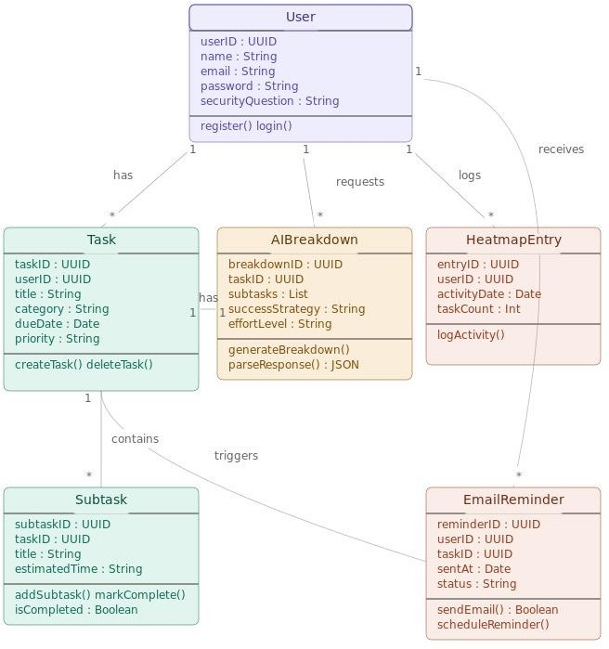
Figure 2 Class Diagram for Tasklyics

The class diagram shown in Figure 2, This diagram shows the architecture and interrelation of the basic elements included in the Tasklyics, such as the User, Task, AIBreakdown, Subtask, HeatmapEntry, and EmailReminder classes. These basic classes contain certain attributes and operations which make up their respective responsibility in the system. For instance, the User class will be involved in managing all issues related to user registration and authentication. Likewise, the Task class is responsible for the management of tasks. Additionally, the AIBreakdown class uses artificial intelligence to generate various subtasks, effort estimations, and productivity advice that helps in managing complicated tasks. The other classes include the Subtask which helps break down tasks, the HeatmapEntry which collects activity information to be used in creating productivity heatmaps like on GitHub.

Moreover, it is evident from the diagram how these objects interrelate, based on the practical workflow of the application. One particular User may create and manage many different Tasks, ask for many AI Breakdowns, receive many Email Reminders, and create many Heatmap Entries, showing that it is all about one-to-many relations. Moreover, one Task may include many Subtasks, which allows managing tasks hierarchically, while the AIBreakdown object remains tightly associated with tasks in order to facilitate intelligent planning. By distributing responsibility among classes and making sure that each of them is responsible for a specific aspect of functionality, the designer made the system more modular, easy to maintain, and scalable. In this way, the created class diagram may be used as the basis for backend development.

5.2 USE CASE DIAGRAM
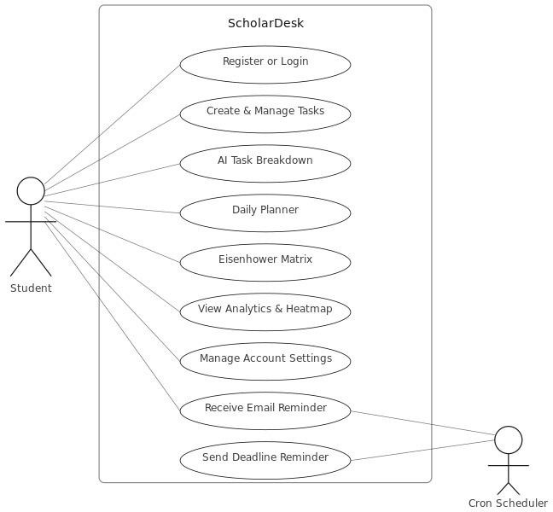
Figure 3 System Use Case Diagram for Tasklytics
Figure 3 shows the Use Case Diagram for the ScholarDesk: AI-Powered Student Productivity and Task Management System, depicting the functions and interactions within the system. From the use case diagram, the two identified actors include the Student who is the main actor using the application and the Cron Scheduler that is an automated background process used to send reminders. Among the functions used by the Student are Register/Login used for user authentication, Create & Manage Tasks to help students manage tasks, AI Task Breakdown to help create an action plan, Daily Planner to improve student productivity, and the Eisenhower Matrix to assist in organizing student activities.
The use case diagram shows other functions such as analytics and notifications related functions. For instance, students may access 'View Analytics & Heatmap' to keep track of their productivity trends and task completion. On the other hand, there is an option to modify their profile data by accessing 'Manage Account Settings'. The use case makes sure that there is some notification regarding deadline dates to ensure that the students remain informed about their academic duties. The actor 'Cron Scheduler' interacts with actors 'Send Deadline Reminder' and 'Receive Email Reminder'.
This implies the process of monitoring task deadlines at regular intervals to automatically send out reminders without any need for user interaction.

IMPLEMENTATION

6.1 TECHNOLOGY USED

The AI-Powered Student Task Management System uses a three-tier architecture with React.js in the front end, Node.js/Express.js at the back end, and MySQL database, along with Google Gemini 2.5 Flash API that acts as the AI service. In this part, we will discuss the technologies used in the AI-Powered Student Task Management System as well as the various modules that make up the system, not just describing the functionality of each technology or module in isolation but also detailing how they work together.
6.1.1 System Architecture Overview
This system employs a client-server architecture where the client and server components are deployed independently while communicating through RESTful API layer. The client is made using React.js and is a pure browser-based application with all its logic residing in the browser. It renders the UI, manages the state, and sends HTTP requests to the backend. At the backend, Express.js server handles those requests, implements the necessary business logic, talks with MySQL database to store/retrieve data persistently, and returns responses in JSON format. In case the request requires the help of any AI-powered features, then the Express.js server makes a call to Google Gemini 2.5 Flash API.
6.1.2 Frontend Technologies
React.js serves as the basis of the frontend. The whole UI is implemented in the form of Single Page Application, i.e., only the application itself is downloaded in the browser and further page loading is accomplished by navigation through SPA pages. React allows implementing each page of the app — dashboard, task manager, Eisenhower Matrix, and analysis page — as an isolated component with independent internal state and rendering logic, resulting in immediate responses to user input.

React Router implements navigation within SPA. The routes are secured using a custom guard component that performs authorization based on the JWT token and redirects unauthorized users to the login page.
For visualization of productivity analytics charts, Recharts library is utilized. Line charts and bar charts showing such metrics as progress of task completion, workload of each task category, or effort breakdown of tasks in a selected period are displayed as dynamic charts generated according to data obtained from the server. Also, GitHub-style task activity heat map showing daily density of completed tasks is visualized using a chart component mapping task completion numbers to color intensity levels.

6.1.3 Authentication & Sessions
Users' identities are handled through JSON Web Tokens (JWT). Upon receiving correct credentials, the backend server verifies the credentials against the database and, if verified successfully, creates a new JWT, signing it with a secret key defined as an environmental variable. The token is returned back to the client, where it gets saved in the local storage. Every subsequent request sent by the frontend includes the saved token within the Authorization header. On the backend, a custom-made Express middleware function processes all requests for secured routes and verifies whether the token's signature and expiration date have not been tampered with before the handler of the corresponding route receives the request. In case of failure, the middleware sends an HTTP status code 401 - 'Unauthorised'.

The users' passwords are never saved in plain text. In the registration procedure, the password passed along with other credentials goes through bcrypt, which is a crypto library implementing hashing with salting and several hashing rounds to be then saved in the database. Bcrypt performs a comparison during authentication without having access to the actual plain text password.

6.1.4 Backend and API Layer
The backend utilizes Node.js and Express.js frameworks. Node.js offers the runtime environment that runs JavaScript on the server using event-driven and non-blocking I/O architecture optimized for concurrency in serving multiple API requests. Express.js supplies the routing framework used to organize all API routes.

The backend is organized into separate folders according to the modular MVC-like architecture with routes, controllers, services, and middleware isolated in their respective folders. Routes file contains URL paths and HTTP methods associated with a feature module (e.g., /api/tasks). The controller function processes the request and calls the related service function to process the actual logic and prepare the output response. Thus, the modification of database logic does not affect routes and vice versa.

Each system operation is available via RESTful API endpoints such as registering/logging in the user, performing CRUD operations on tasks and subtasks, making requests to get tasks broken down by the AI, aggregating analytics data, and managing user settings. All endpoint responses contain the structured JSON payload with standard status codes and structured error messages handled globally.

6.1.5 Database Layer
MySQL 8.0 acts as the relational database management system and runs on Aiven Cloud for reliable access and automatic backup. The database schema is normalised and comprises several tables: users, tasks, subtasks, security questions and user settings, all linked by appropriate foreign key relationships. For instance, when a particular task is removed from the database, all its subtasks are also removed via cascading delete operation.

A pool of existing connections maintained between the backend and MySQL database is established by means of mysql2 driver in Node.js. Instead of creating and destroying a new connection every time an API call occurs (an approach that can lead to performance issues), a pool of connections reuses already open connections, thus improving speed.

Commonly used fields (e.g., user_id, due_date, and status) are indexed for better performance with queries involving sorting or searching tasks.

6.1.6 AI Integration
Task decomposition using AI functionality is carried out via the Google Gemini 2.5 Flash API. The process starts when the user requests an AI-driven task decomposition. In response to this request, the backend builds a structured request including the title of the task, the task description, and the category of the course. This request is then sent to the AI API endpoint via an HTTPS POST request. The AI decomposes the request into four to six subtasks that are logically ordered, together with an estimated time required to complete each task. Moreover, the user gets a personalized approach on how to study the course and how difficult it is in terms of time needed to learn.

The backend analyzes the returned response from the Gemini AI API, and saves generated tasks in the database, ready to show them to the user. Due to the fact that using an external API introduces extra delays and failures, the system implements timeouts and failsafe functionality. If the Gemini API does not return the data on time or the API response cannot be analyzed due to errors, the backend builds the default list of subtasks depending on the course category.

6.1.7 Background Services and Email Notification
The automated notification system is developed as a node-cron job that executes once daily from the backend server. It checks the database for all the tasks that have a deadline set for the following day and fetches the corresponding email address of those users. Then it sends a formatted HTML mail via Nodemailer, which is an SMTP-based email sending library, that contains the task name, category of the course, deadline, and a call-to-action. No SMTP credentials are hard-coded into the source code and they are only kept in the environment variables.
It works independently and without affecting the performance of the API server as it is executed asynchronously when there is no traffic.

6.1.8 Deployment and Environment Setup
The React-based frontend app is deployed through Vercel, where static content delivery is facilitated via CDN and HTTPS support comes automatically; the latter occurs every time a push occurs in the primary Git branch. The backend is powered by an Express.js application running on Node.js and is hosted on Render, a cloud computing environment that allows for deploying the app as a persistent web service. MySQL database is hosted through Aiven Cloud, which automatically performs backups and connection encryption.

All sensitive data required for successful operation, such as the JWT secret, the key for the Gemini API, the MySQL connection URI, and SMTP settings, are stored in environment variables on each of the hosting platforms separately, thus ensuring their absence from the codebase altogether. It should be noted that the frontend and backend applications can be deployed independently from one another.

6.2 SCREENSHOTS

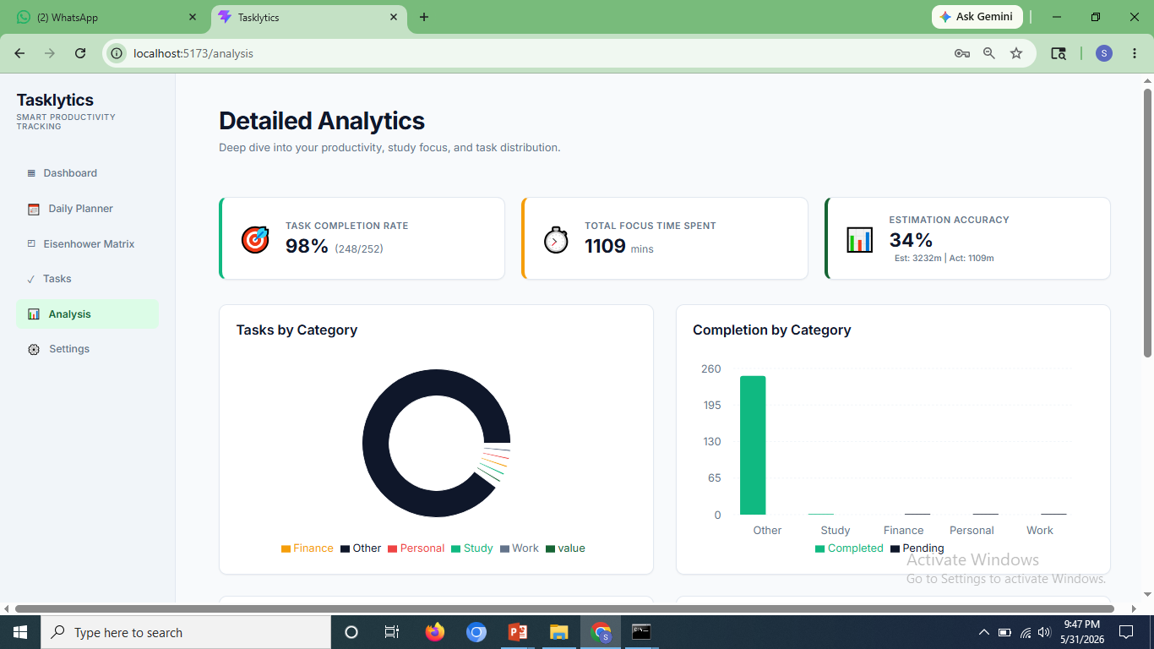
Figure 4 Analytics Page in Tasklytics-1

The page in Figure 4 shows the performance indicators task completion rate, total focus time spent and estimation accuracy and charts like task by category and compleion by category

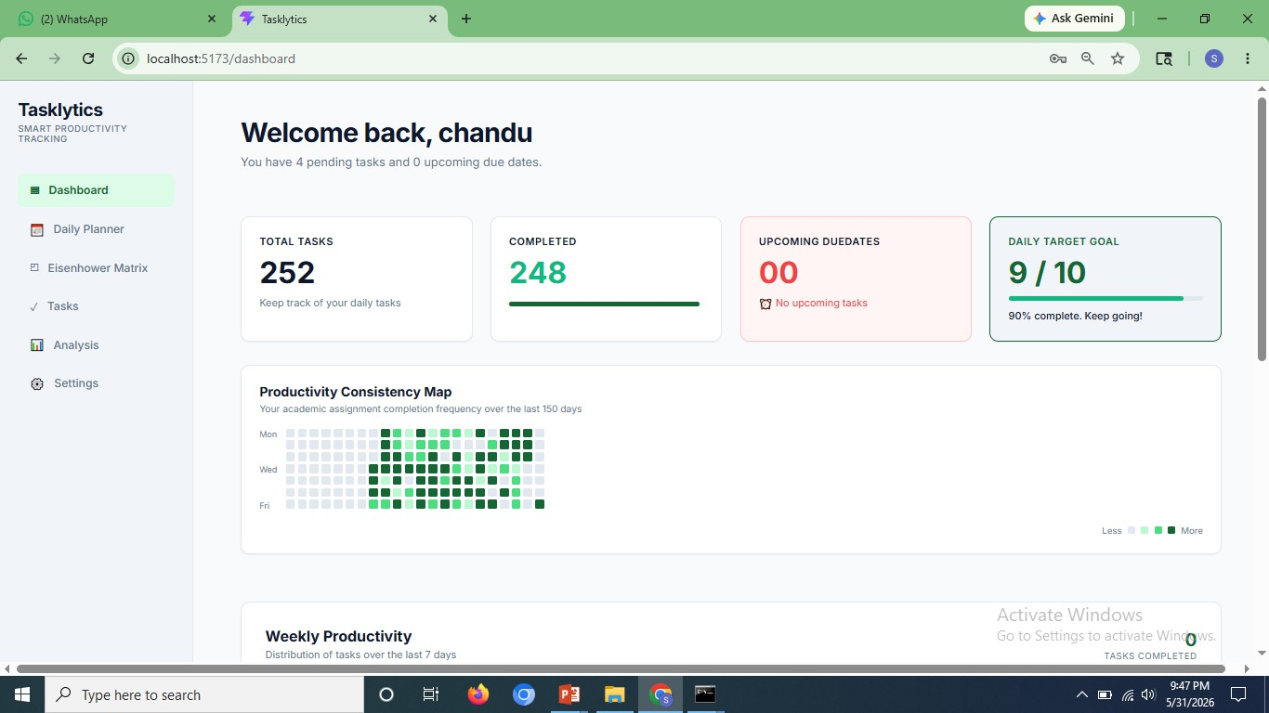
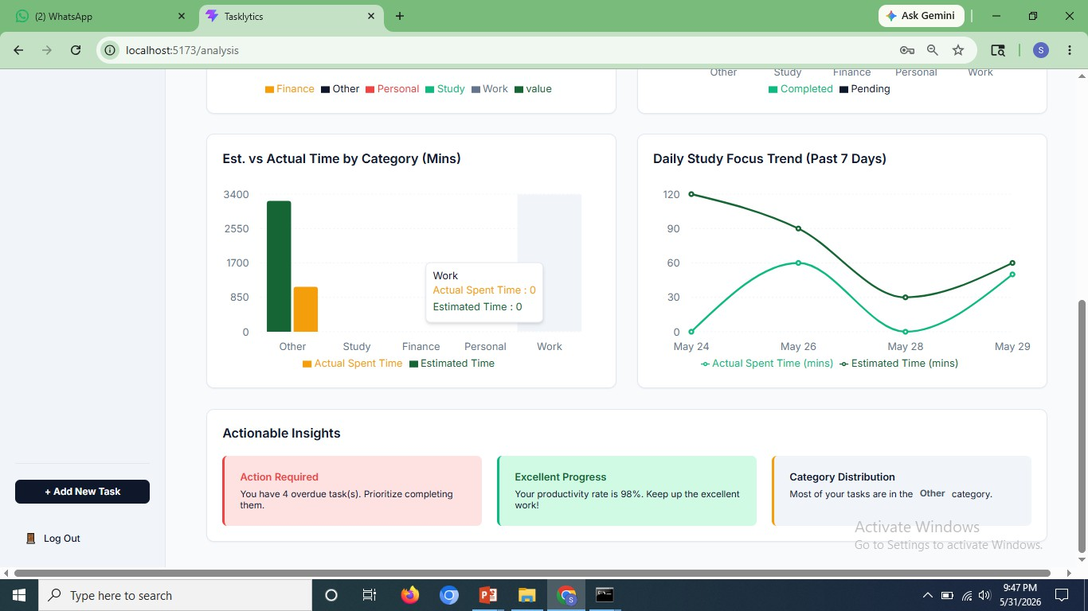
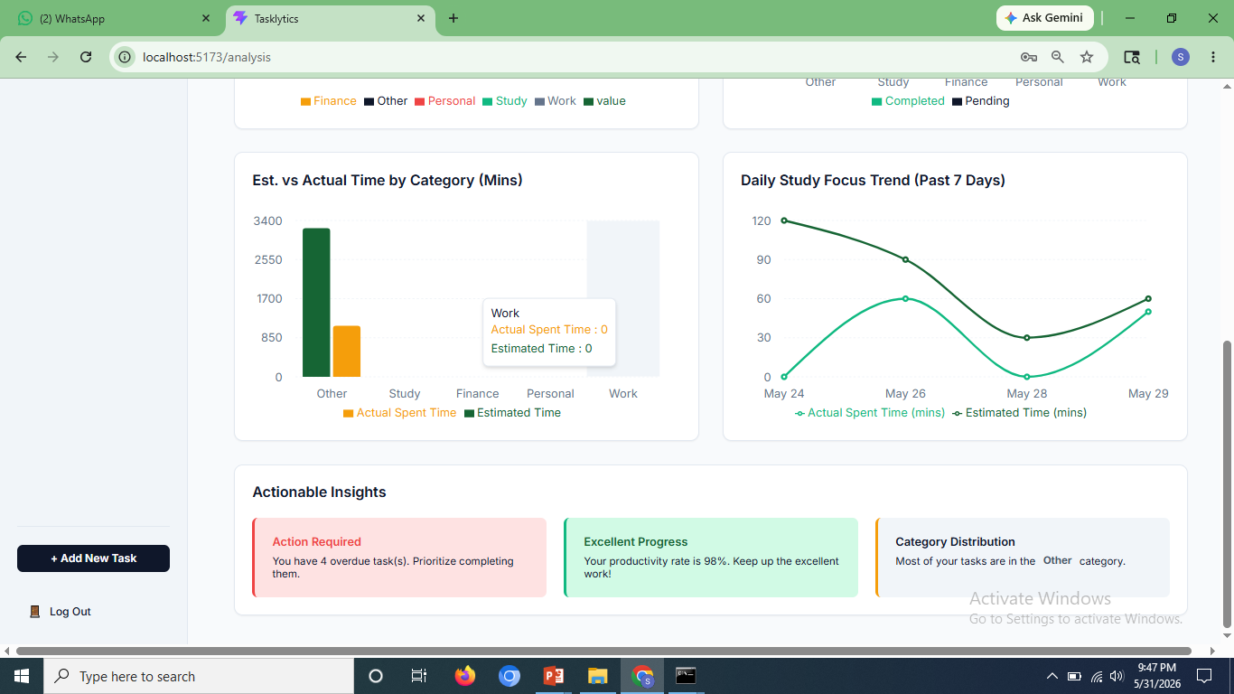
Figure 5 Anylitics Page in Tasklytics-2

In Figure 5 we have two other graphs which follow the Analysis page. In the grouped bar graph "Est. vs Actual Time by Category (Mins)," there is a tooltip at work category where Actual Spent Time is 0 and Estimated Time is 0. Another graph is the line graph which shows daily study focus trend (past 7 days). This graph has plotted the actual and estimated time from 24 May to 29 May. Under the graphs, there are three actionable insights' cards. These cards include an alert about "Action required" with four overdue task and a card of "excellent progress" with a productivity rate of 98%.

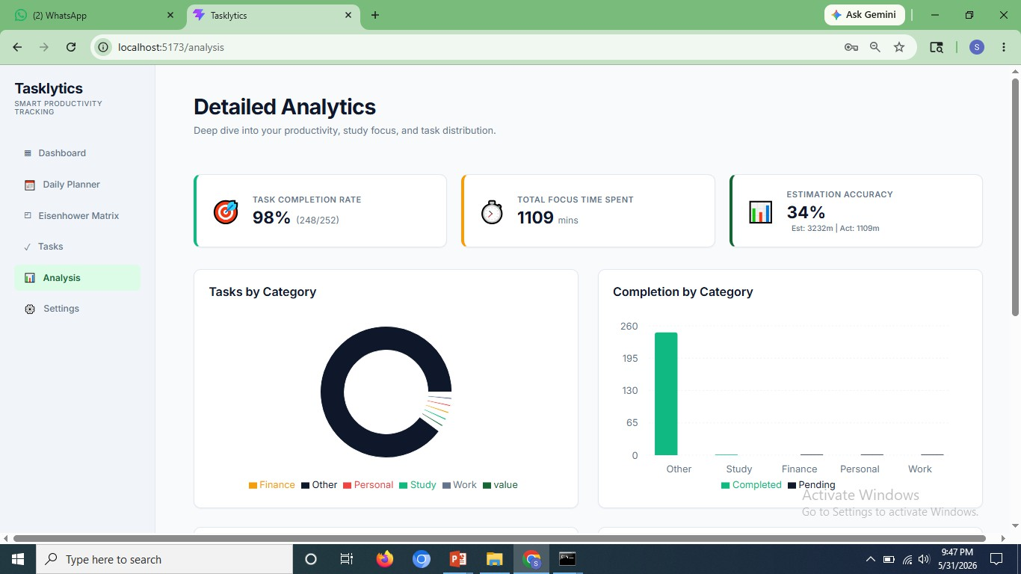
Figure 6 Dashboard of Tasklytics

In Figure 6, The dashboard greets the logged-in user by the name “chandu” and also indicates four pending tasks and zero due dates. Four cards appear showing “Total Tasks” (252), “Completed” (248), “Upcoming Due Dates” (00 - No upcoming tasks), and “Daily Target Goal” (9/10 - 90% completed). Below these cards is shown a “Productivity Consistency Map” which displays productivity on the basis of frequency of task completion within the last 150 days in a heat map format. The weekly productivity starts from there.

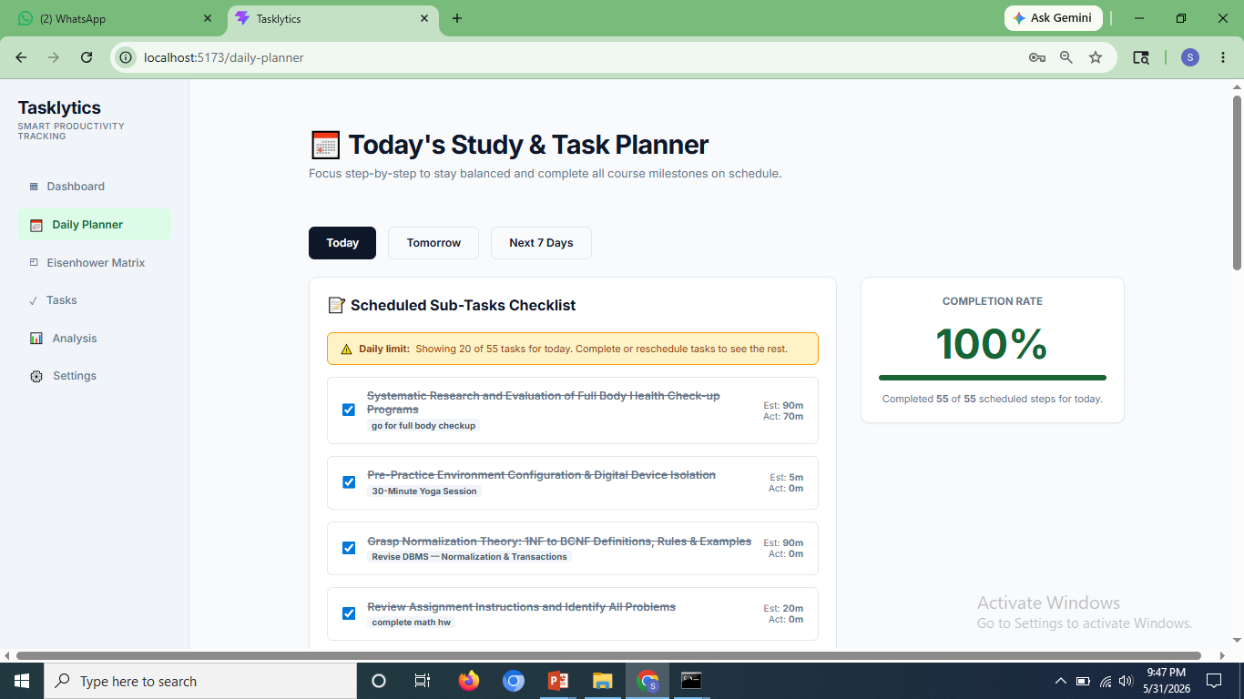
Figure 7 Task Planner in Tasklytics
In Figure 7, Title of the Daily Planner page is "Today's Study & Task Planner" which says "Focus step-by-step to stay balanced and accomplish all course objectives on time." There are three tabs available such as Today, Tomorrow and Next 7 Days. The Today tab displays a "Scheduled Sub-tasks Checklist" with a daily limitation warning (20 out of 55). Many accomplished tasks can be seen with the help of strikethrough words, some of which include "Systematic Research and Evaluation of Full Body Health Check-up Programmes" (Estimated: 90m, Actual: 70m), "Environment Preparation and Isolation of Digital Device(s)" (Estimated: 5m) and academic tasks such as DBMS normalization and maths homework. On the right hand side, there is a Completion Rate showing 100%, meaning that all 55 scheduled tasks have been completed for today.

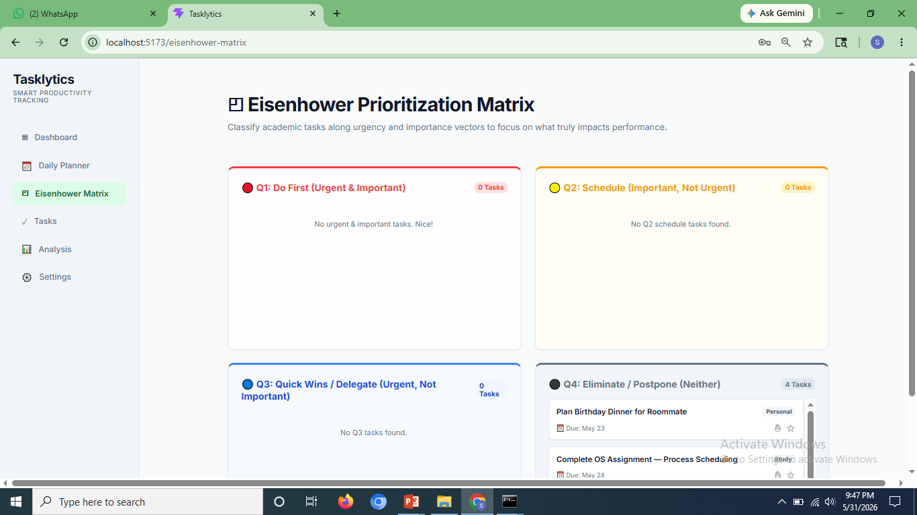
Figure 8 Prioritization Matrix in Tasklytics
In Figure 8,The page arranges the tasks under four quadrants that depend on urgency and importance. The first quadrant is known as Do First, and its description is Urgent & Important. This quadrant currently has no task and displays “No urgent & important tasks. Nice!” The second quadrant is called Schedule because its description includes Important, but not urgent (orange border), and it has no task. The third quadrant has the description Urgent, but not important (blue border). It also has no task. The fourth quadrant has a dark border and shows 4 tasks.
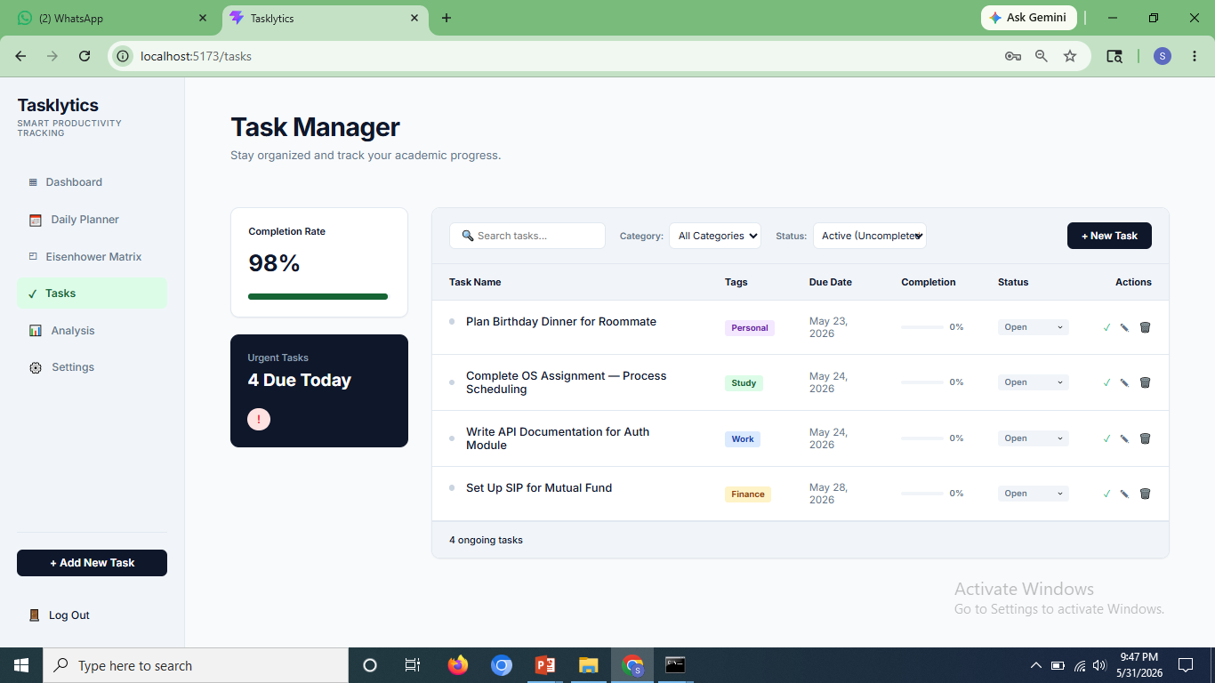
Figure 9 Task Manager in Tasklytics
In Figure 9, In the Task Manager page, users can organize and monitor their tasks. There is a sidebar where the completion rate is noted as 98%, and there is an "Urgent Tasks" banner that mentions 4 urgent tasks which need to be completed today. There is a task listing section where all the tasks can be filtered using Category and Status. There are four ongoing (not completed) tasks listed in a tabular form under the following headings: Task Name, Tags, Deadline, Completion %, Status, and Actions. These are: Plan Birthday Dinner for Roommate (Personal, May 23), Complete OS Assignment — Process Scheduling (Study, May 24), Write API Documentation for Auth Module (Work, May 24), and Set Up SIP for Mutual Fund (Finance, May 28).

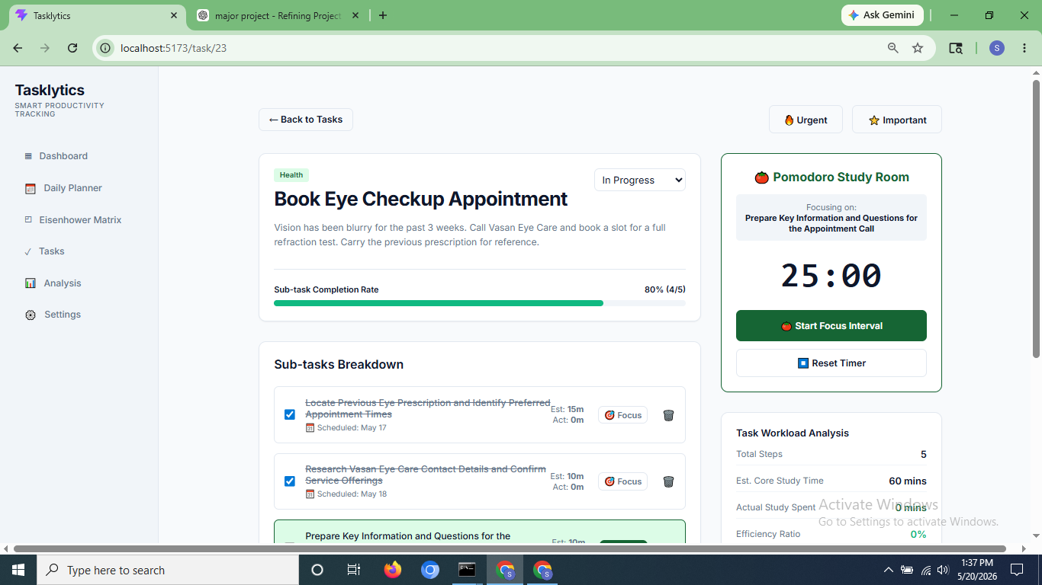
Figure 10 Page of Task Book Eye Checkup Appointment
In Figure 10, the Task Detail Page of the task “Book Eye Checkup Appointment” (URL: /task/23), which is classified under Health and tagged as Urgent and Important, reveals that the task is currently “In Progress,” requiring the user to contact Vasan Eye Care Clinic to schedule an appointment for refraction check-up test. Its sub-tasks' completion percentage is 80%, represented by the completion bar, where the remaining 20% refers to the unfinished sub-task, namely, "Prepare Key Information and Questions for the Appointment Call." In the Sub-tasks Breakdown section, four sub-tasks have already been completed – find the prescription made earlier and get some information about the eye clinic. On the right, there is a Pomodoro Study Room where its countdown timer shows 25:00, reflecting the active sub-task, with Start and Reset buttons provided. Below, the Task Workload Analysis shows that there are five total steps, 60 minutes study time estimate, no actual time spent, and 0% efficiency level.

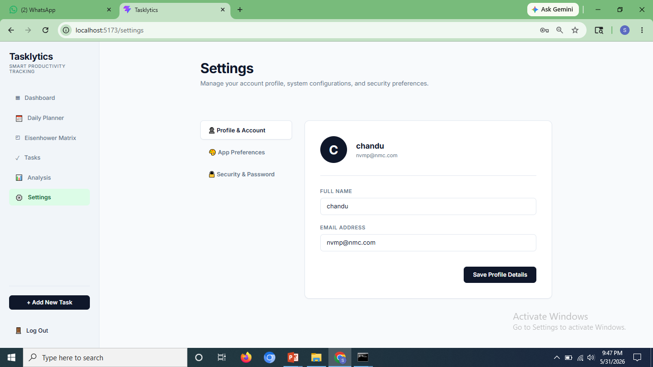
Figure 11 Settings Page in Tasklyics
In Figure 11, Settings is divided into three sections through the left tabs bar: Profile & Account, Application Preferences, and Security & Password. The Profile & Account tab is currently selected and displays the profile picture of the user with initial C, the username as chandu, and email address nvmp@nmc.com. There are options to edit the fields Full Name and Email Address along with Save Profile Details.

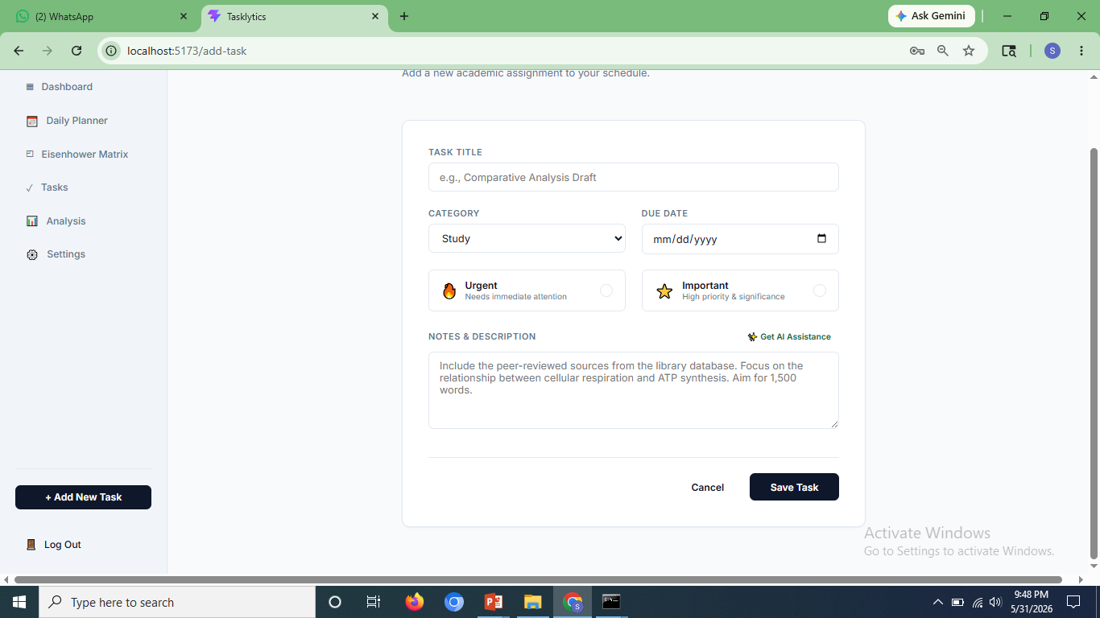
Figure 12 Add New Task Page in Tasklyics
In Figure 12, In the form for adding a task, users are provided with the ability to create an academic task. Form fields are “Task Title” (with placeholder text – “e.g., Comparative Analysis Draft”), “Category” (drop-down field with default value – “Study”), and “Due Date” (date picker). The following two toggles can be checked if the task is urgent (requires immediate action) or important (high priority/level of significance). The placeholder for “Notes & Description” text area describes the research task. The “Get AI Assistance” button is located next to the description label.

TESTING
Testing plays an important role in the implementation stage of software systems since it checks whether the developed system performs as expected under different scenarios. Testing of the AI-Powered Student Task Management System involved testing of the individual modules using a set of predetermined test cases per module. The test cases included information on the description, the input values, the expected response from the system, the real result obtained, and finally, the pass/fail judgment. In case a test case fails, a necessary correction would be made and tested again as another entry. The test results for each module follow as discussed below.

7.1 User Registration and Login Module
Module: The User Registration & Login module acts as the security barrier around the entire application. To use the Task Management features and the AI components, the user has to first register themselves and then log in. Hence, this module underwent extensive testing, which included tests for both the happy paths (valid registration and login), as well as various scenarios that fall outside the scope of a happy path – such as duplicate email registration, incomplete form filling, wrong credentials, and accessing restricted routes without a token.
One such issue detected was during the test case TC-008, wherein the system did not prevent registration despite leaving the password field blank, thus revealing the absence of validation on the server-side. Validation was added to the registration controller to resolve this problem, and the test was re-done in TC-008a. All other test cases went through successfully without any corrections being needed.
Table 3 Test Cases for User Registration and Login Module
Test ID | Test Case Description | Input | Expected Result | Actual Output | Status
TC-001 | Register with valid inputs | Valid name, email, password | Account should be created | Account created successfully | PASS
TC-002 | Register with existing email | Duplicate email | Show "Email already exists" error | Error displayed correctly | PASS
TC-003 | Login with valid credentials | Correct email and password | User logged in and redirected to dashboard | Redirected to dashboard | PASS
TC-004 | Login with wrong password | Valid email, wrong password | Show "Invalid credentials" message | Error message shown | PASS
TC-005 | Access protected page without login | No token | Redirect to login page | Redirected as expected | PASS
TC-006 | Register with invalid email format | Name, invalid email (e.g., user@com) | Show "Invalid email format" error | Error message shown | PASS
TC-007 | Login with unregistered email | Unregistered email, any password | Show "User not found" error | Error message shown | PASS
TC-008 | Registration with missing required fields | Missing password | Show "Password is required" error | No error, registration allowed | FAIL
TC-008a | (Fix) Validation added for missing fields | Missing password | Show "Password is required" error | Error message shown | PASS
TC-009 | Login with empty email and password | Blank email and password | Show "Please fill in all fields" error | Error shown correctly | PASS

7.2 Task Management Module
Correct functioning of the Task Management module is critical for the whole system operation, since errors in the implementation of the module will lead to overall failure of the system operation. Thus, during testing of the task management module, all actions associated with creating tasks, retrieving tasks, applying filters, changing, and deleting tasks were checked, including edge scenarios related to incomplete forms and unauthorized access to data from another user account.
Of special concern was test case TC-018, which ensured that a user could not access or change task data created by someone else. The server response was unauthorised in this situation, so the task management code implemented using JWT to check ownership of data worked properly. All test cases associated with this module were successful.
Table 4 Test Cases for Task Management Module
Test ID | Test Case Description | Input | Expected Result | Actual Output | Status
TC-011 | Add task with valid inputs | Valid title, category, due date, priority | Task created and shown in list | Task added successfully | PASS
TC-012 | Add task with missing title | Empty title field | Show "Title is required" error | Error message shown | PASS
TC-013 | Filter tasks by category | Select course category | Only tasks of that category displayed | Filtered correctly | PASS
TC-014 | Filter tasks by priority | Select "High" priority | Only high-priority tasks shown | Tasks filtered correctly | PASS
TC-015 | Edit an existing task | Update title and due date | Task updated and reflected in list | Task updated successfully | PASS
TC-016 | Delete a task | Click delete on a task | Task removed from list | Task deleted successfully | PASS
TC-017 | View task with no matching filter | Apply filter with no matches | Show "No tasks found" message | No tasks message displayed | PASS
TC-018 | Access another user's task | Different user ID in request | Return 404 or unauthorised error | Unauthorised error returned | PASS

7.3 Subtask and AI Breakdown Module
These two features relate to each other in that both the manually created subtasks and the automatically generated subtasks using the AI use the same underlying data storage mechanism and are shown to the user in the same Task Details page.
The manual subtask test cases — TC-019 to TC-021 — ensured that subtasks could be added, marked as done, and deleted without any impact on the parent task. In addition, the tests for the automatic task breakdown functionality considered three different situations: a valid task where all required fields are filled (TC-022), an invalid task where only the title field is filled (TC-023), and a situation when the Gemini API is not available due to missing API keys (TC-024). In all three cases, the application behaves in accordance with the requirements, and in particular, the fallback procedure in case of missing API keys works flawlessly.
Table 5 Test Cases for Subtask and AI Breakdown Module
Test ID | Test Case Description | Input | Expected Result | Actual Output | Status
TC-019 | Add subtask to a task | Valid subtask title and time | Subtask saved and displayed | Subtask added successfully | PASS
TC-020 | Mark subtask as complete | Click complete checkbox | Subtask marked complete | Status updated correctly | PASS
TC-021 | Delete a subtask | Click delete on subtask | Subtask removed from list | Subtask deleted successfully | PASS
TC-022 | Generate AI breakdown with valid task | Task with title, description, category | 4–6 subtasks, tip, and effort level returned | AI breakdown displayed correctly | PASS
TC-023 | Generate AI breakdown with missing description | Task with title only | Breakdown generated using available fields | Breakdown returned with defaults | PASS
TC-024 | AI breakdown with API unavailable | Gemini API key absent | Fallback subtasks returned | Default subtasks shown | PASS

7.4 Daily Planner Module
The Daily Planner is designed to have a focused scope and displays only those tasks that are to be done on the particular day selected by the user. For testing purposes, this feature was tested against three possible conditions: a user having subtasks assigned to today, a user marking a subtask done right from the planner view, and a user without any subtasks planned for today. The three tests were all successful, which proves that the filtering mechanism for selecting subtasks is correct, and the empty view works as intended.
Table 6 Test Cases for Daily Planner Module
Test ID | Test Case Description | Input | Expected Result | Actual Output | Status
TC-025 | View daily subtasks for current date | Logged-in user | Subtasks due today displayed | Correct subtasks shown | PASS
TC-026 | Mark daily subtask complete from planner | Click complete | Subtask status updated | Status updated correctly | PASS
TC-027 | View planner with no tasks due today | No subtasks scheduled | Show "No tasks for today" message | Message displayed correctly | PASS

7.5 Analytics and Heatmap Module
The Analytics & Heatmap module provides visual interpretation of task data, and its functionality relies upon aggregation queries being correctly written in the database side as well as proper rendering mechanisms on the front end side. A total of three tests were conducted for the module: test with a user who had task data already to check that graphs would render with the right data; test with a user who already completed his/her tasks to confirm that heat map shows correct density; and test with a newly registered user who did not have any task data yet to ensure that the dashboard will render properly with the empty state without crashing or showing erroring graph components..
Table 7 Test Cases for Analytics and Heatmap Module
Test ID | Test Case Description | Input | Expected Result | Actual Output | Status
TC-028 | Load analytics dashboard | Logged-in user with tasks | Charts render with correct data | Charts displayed correctly | PASS
TC-029 | View heatmap with activity | User with completed tasks | Activity grid shows correct density | Heatmap rendered correctly | PASS
TC-030 | View analytics with no tasks | New user with no data | Show empty state or zero values | Empty state shown correctly | PASS

7.6 User Profile and Settings Module
Settings module handles account-related actions such as modification of profiles, changing passwords, and management of security questions by users. Test procedures included successful modification attempts and invalid inputs, where a wrong password was entered while trying to change the password. TC-037 ensured that the system does not approve the modification of the password and responds with a meaningful error message. Five test cases were performed within this module, all of which resulted in passing.
Table 8 Test Cases for User Profile and Settings Module
Test ID | Test Case Description | Input | Expected Result | Actual Output | Status
TC-034 | View user profile | Logged-in user | Show name, email, and profile details | Profile displayed correctly | PASS
TC-035 | Update profile information | Edit form and submit | Info updated and reflected | Profile updated successfully | PASS
TC-036 | Change password with correct old password | Old + new password | Password updated successfully | Password changed | PASS
TC-037 | Change password with incorrect old password | Wrong old password | Show "Current password incorrect" error | Error message shown | PASS
TC-038 | Update security question | New question and answer | Security question updated | Updated successfully | PASS

7.7 Summary of Test Results
For all the seven modules, a total of 38 test cases were conducted, out of which there is 1 re-test due to a change in correction. Out of these test cases, 37 passed upon their initial attempt. There was only one test case failure, i.e., Test Case-008, where it was found that there is no validation done on the password box at the server side when the user signs up for registration. This bug was fixed by applying the validation condition in the registration controller, and the corrected functionality was tested again in TC-008a.

IMPACT ON SOCIETY AND ENVIRONMENT

8.1 Impact on Society

Tasklytic makes a considerable impact on improving how students organize and handle their student responsibilities. Thanks to having a smart and easy-to-use digital tool, it allows people to make better judgments about their learning styles and time management. By including elements like AI task breaks, personalized success plans, a daily planner, and deadline alerts, studying becomes easier for those individuals who find it difficult to organize themselves and cannot afford student coaching or tutoring.

The platform also encourages the emerging culture of self-improvement and study wellness by introducing structured planning, regular efforts tracking, and workload awareness. Through the use of tools like an Eisenhower Matrix and productivity heatmap, students gain insight into their priorities and study behavior, developing good habits in the process. Moreover, through the centralization of tasks and smart recommendations, it minimizes student stress caused by deadline fears.

Overall, on a wider scale, the project showcases the potential of AI technology as far as its democratization is concerned, which means making effective use of it in educational settings despite the lack of expensive institutional infrastructures required to do so. Regardless of their social status, students may benefit from the same level of student planning with the help of AI as they would pay for when using productivity software or getting private tutoring sessions.

8.2 Impact on Environment

While digital platforms tend to have a more minimal direct impact on the environment than physical infrastructure, environmental consequences related to cloud computing in supporting web applications should not be overlooked either. Tasklytic's complete transition from traditional methods of planning tasks and organizing work by removing printed planners, old-school to-do sheets, and study organizers contributes to minimizing the usage of paper products.

In addition to this, Tasklytic's reminder feature eliminates the use of print-out reminder sheets, as well as replacing the necessity of having a physical notice board. Cloud-based implementation of the application using third-party platforms like Vercel reduces the need for maintaining energy-intensive on-premise servers, as the serverless solution only utilizes computational resources when necessary.

Nevertheless, the energy usage related to making API calls and using services of a large-scale language model like Google Gemini cannot be overlooked. To counteract the negative effect of using Google Gemini, Tasklytic utilizes a deterministic fallback mechanism for when the service is down and does not make unnecessary API calls. Prompts are designed to be brief and precise to reduce the number of tokens used.

By advocating for proper digital management of students and by making responsible choices in engineering, Tasklytic acts as an effort to find the balance between convenience, intelligent personalization, and sustainability in education technology software.
.

CONCLUSION

Tasklytic's development, which is an AI-assisted student task management platform, was intended to provide a solution that would cater to the shortcomings of generic productivity applications by providing an intelligent, custom-built and performance-oriented platform specifically developed for students. Tasklytic supports students' tasks and subtasks management, generation of task breakdowns with the help of AI technology, visualization of productivity analytics, and deadline reminders, all of which are required by student users to facilitate more efficient completion of academic assignments.

In terms of technical features, Tasklytic uses user authentication, CRUD operation for task and subtasks, AI powered by Google Gemini, daily planner, Eisenhower matrix task prioritization, productivity heatmap, and email reminders using cron jobs. Code reusability and modularity were made possible with the use of React.js and component-driven architecture, whereas the fully responsive web design allowed for the best performance on all types of devices. At the server-side, non-blocking, scalable, and easy-to-maintain server architecture was achieved with the help of Node.js and Express.js, while MySQL offered efficient storage of structured relational data. JWT authentication and well-designed APIs helped protect user's sensitive information, whereas modular routes enhanced the scalability of the application.

Tasklytic has provided an invaluable learning opportunity for full-stack development, RESTful API development, AI API integration, database design, scheduled background tasks, and cloud implementation. Testing has been performed at every stage of the process, including unit testing on each component, testing of APIs using Postman, and integration testing to ensure proper interaction of frontend and backend solutions. This helped in guaranteeing that the system operates seamlessly without any hiccups.

In general, Tasklytic has improved technical competencies within the team and shown that with the correct design approach, intelligent use of features, and engineering, we are able to build a high-quality and scalable solution designed specifically for students' needs.

FUTURE ENHANCEMENTS

Tasklytics can be further enhanced in the following ways:

- Collaborative Study Groups
The development of Collaborative Study Groups will be another great way to enhance the functionality of Tasklytic in the future. Collaborative Study Groups will enable students to complete their assignments, projects, and other learning activities as a group within a common environment. In such groups, users will have an opportunity to assign and manage tasks collectively, divide assignments into sub-tasks, track progress, receive notifications about tasks' completion, and much more.

To organize efficient collaboration, Tasklytic can offer such functionality as role-based access control in which each user will have access to certain features depending on his role within a particular group. For instance, there may be such roles as Group Owner, Editor, and Viewer who will have various permissions and possibilities according to their positions. This feature will allow organizing efficient teamwork and learning process.

Integration with Learning Management Systems (LMS)

Another way to improve the functionality of the Tasklytic system in the future is its ability to be integrated with some Learning Management Systems, including Moodle, Google Classroom, and Canvas. In this case, all assignments, due dates, course announcements, and student academic schedules would automatically be synchronized with the task manager. Students would be able to avoid making manual entries and thus save time and make sure that all academic tasks are timely updated.

With automated synchronization of academic information, Tasklytic could become a dashboard where students have all relevant details regarding their studies. Students could manage various tasks coming from different subjects and courses without any delays since they could rely on automated updates and reminders. Integration with other learning platforms would make it easier for students to stay organized and manage their workload.

Advanced Analytics and Personalised Insights
One possible future enhancement for Tasklytic may involve the incorporation of Advanced Analytics and Performance Insights to allow students to gain further insight into their study techniques. By using advanced analytics to examine the patterns of task completion, studying time, and academic activity, the system could provide subject-based performance trends, week-end productivity summaries, and study consistency statistics.

Not only would these features allow students to benefit from the software but also provide comprehensive reporting capabilities for instructors and universities. The system could potentially incorporate analytics systems such as Google Analytics and create its own dashboards for tracking user activity and platform engagement. This would provide administrators with information needed for data-driven decision making and improvements in student productivity.

11. BIBLIOGRAPHY
- Express.js Foundation. (n.d.). Express Documentation. Retrieved from https://expressjs.com
- React Official Documentation – Meta. (n.d.). React Docs – A JavaScript library for building user interfaces. Retrieved from https://react.dev
- Node.js Documentation – OpenJS Foundation. (n.d.). Node.js Documentation. Retrieved from https://nodejs.org/en/docs
- MySQL Documentation – Oracle Corporation. (n.d.). MySQL 8.0 Reference Manual. Retrieved from https://dev.mysql.com/doc
- mysql2 – npm Registry. (n.d.). mysql2 – Fast MySQL driver for Node.js. Retrieved from https://www.npmjs.com/package/mysql2
- Google Generative AI – Google LLC. (n.d.). Gemini API Documentation. Retrieved from https://ai.google.dev/docs
- Nodemailer – Nodemailer. (n.d.). Nodemailer – Send emails from Node.js. Retrieved from https://nodemailer.com
- node-cron – npm Registry. (n.d.). node-cron – Task scheduler for Node.js. Retrieved from https://www.npmjs.com/package/node-cron
- JSON Web Tokens – Auth0. (n.d.). Introduction to JSON Web Tokens. Retrieved from https://jwt.io/introduction
- bcrypt – npm Registry. (n.d.). bcrypt – Password hashing library for Node.js. Retrieved from https://www.npmjs.com/package/bcrypt
- Vite – Evan You & Vite Contributors. (n.d.). Vite – Next Generation Frontend Tooling.
Retrieved from https://vitejs.dev
- W3Schools – W3Schools.com. (n.d.). HTML, CSS, JavaScript Tutorials. Retrieved from https://www.w3schools.com
- MDN Web Docs – Mozilla Developer Network. (n.d.). Web technology reference. Retrieved from https://developer.mozilla.org
- GitHub – GitHub Inc. (n.d.). Open-source project collaboration and version control. Retrieved from https://github.com
- GeeksforGeeks. (n.d.). Full Stack Development Tutorials and Concepts. Retrieved from https://www.geeksforgeeks.org
- Figma – Figma Inc. (n.d.). Collaborative Interface Design Tool. Used for UI wireframing and prototypes. Retrieved from https://www.figma.com

